
WINTER EMERGENCY AID FOR KYIV

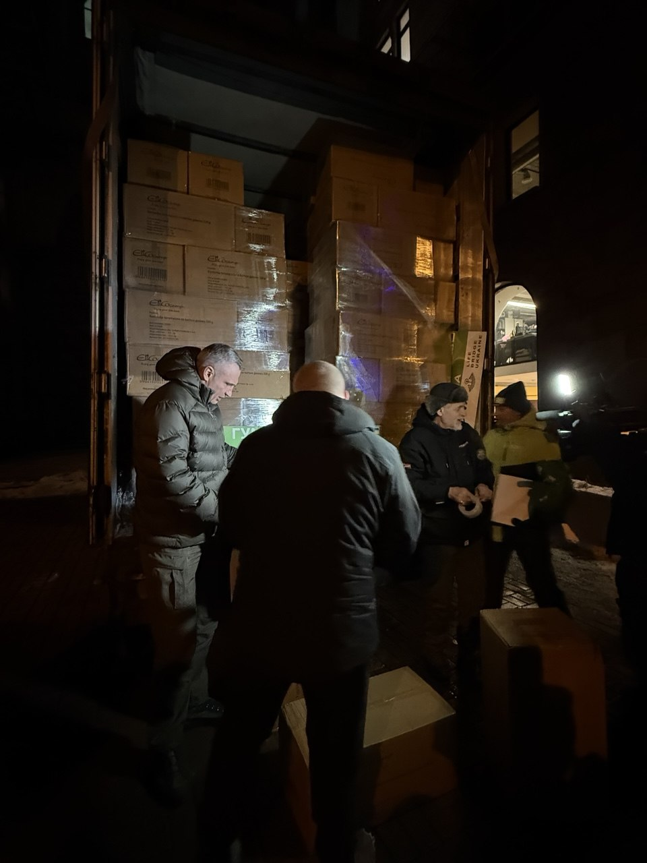
In January and February 2026, Kyiv experienced one of the coldest winters in recent years – with temperatures well below freezing and an icy wind.
Within just two weeks, thanks to our supporters, we were able to raise a total of 172,125.41 euros for urgent winter relief – and, at the same time, purchase thousands of gas camping stoves, hot water bottles and gas cartridges in Poland. The initial ‘start-up capital’ was provided to us in Berlin by the Berliner Kaufleute und Industrieller e.V. (VBKI), thereby giving us the necessary security to launch the project.
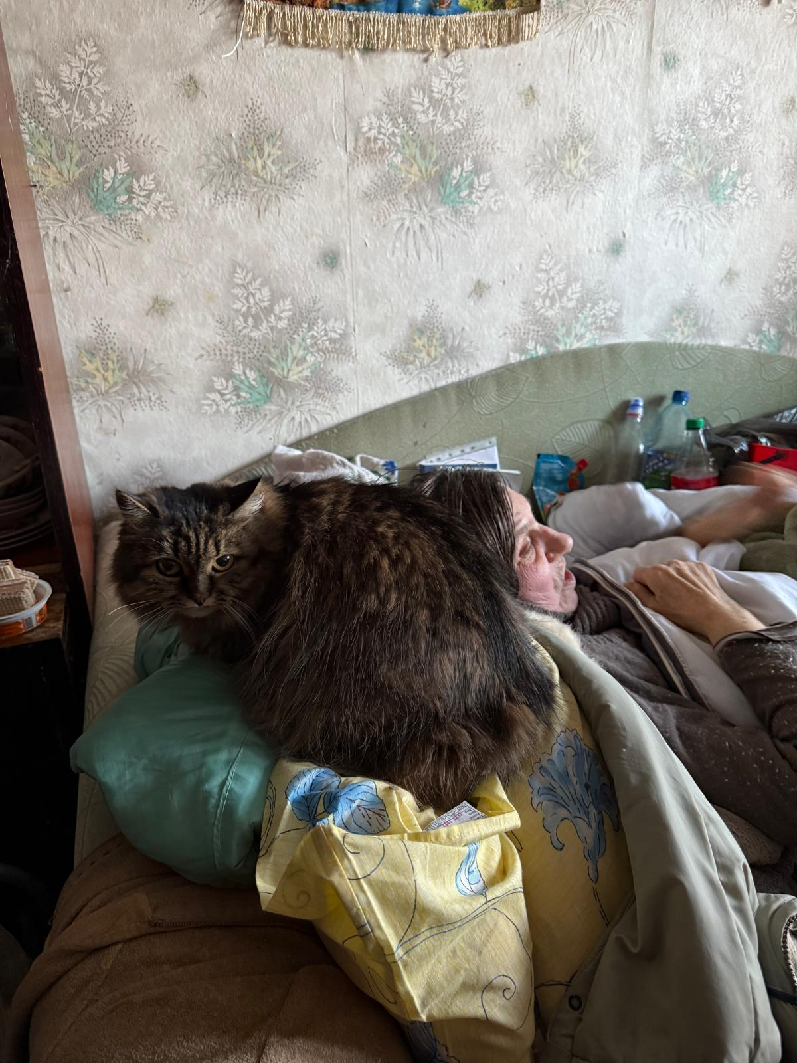
Using the funds raised, we were able to finance 9,500 gas camping stoves, 58,000 gas cartridges, 10,580 hot water bottles, as well as bags, sacks and transport for two major relief operations, thereby helping thousands of people in need.
With our first aid convoy, we travelled to Kyiv at the end of January 2026 and, in collaboration with Kyiv City Administration and with the personal support of Mayor Vitalii Klitschko, the social services departments and the ‘Strong with Ukraine Foundation’, we packed thousands of winter emergency parcels and distributed them to the worst-affected households.
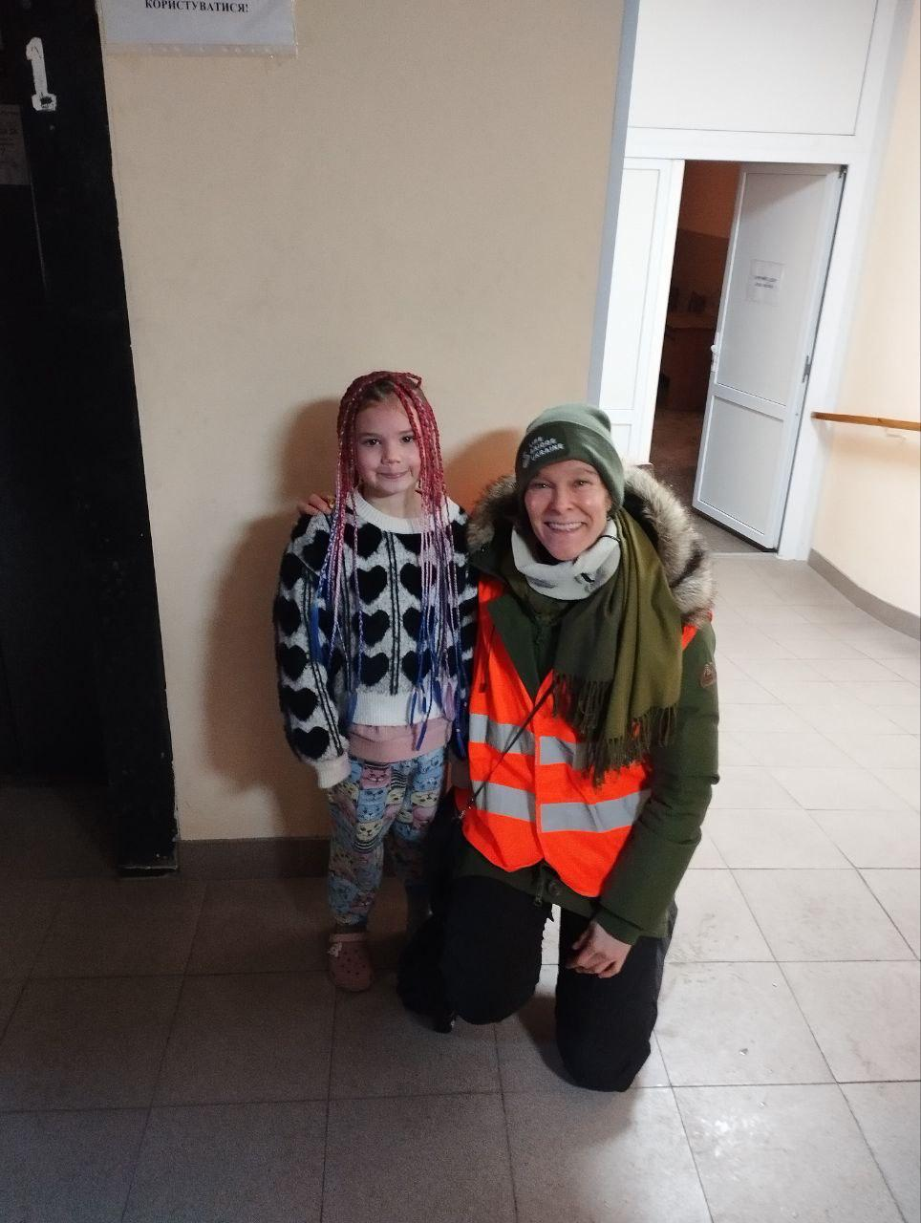
We distributed the winter emergency parcels directly to vulnerable people: households on very low incomes, older people, children and families living in severely damaged residential buildings, as well as households without reliable access to gas, heating or electricity.
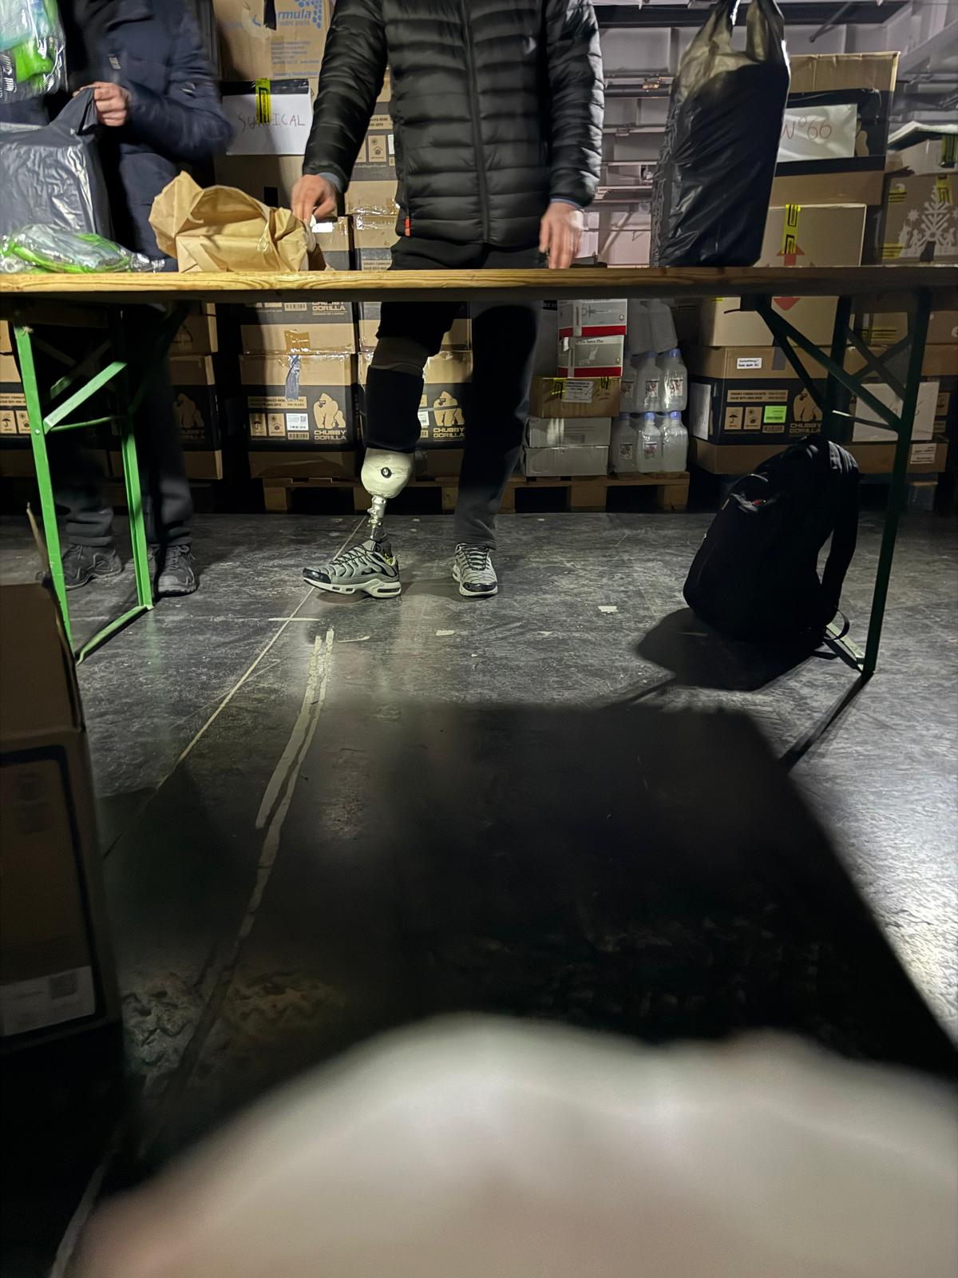
We are particularly proud that the men and veterans whom we were able to help get back on their feet with high-quality prosthetics at the Berlin-Kyiv Municipal Prosthetics Centre (Human-Titans) have, in turn, supported us in providing this emergency aid to the civilian population.

We remember the ice-cold hands that accepted our help from our warm hands – and the silent, grateful eyes that looked at us.
These encounters show us just how vital warmth, closeness and practical help are for survival in this war.
Thank you to everyone who made this winter emergency aid possible!!!

Dr Janine v. Wolfersdorff
Life Bridge Ukraine, 1 June 2026,
contact@life.bridge-ukraine.com,

